2 datasets used

1. Weighted prices for all products
2. Weighted prices for each contract period for WMP products

------------------------------------------------------------------------------------------------------------------------------------------

Work with a weighted prices

dat$Event.Date <- as.Date(dat$Event.Date, "%m/%d/%Y")

Analysis

> plot(x = dat$Event.Date, y = dat$WMP)

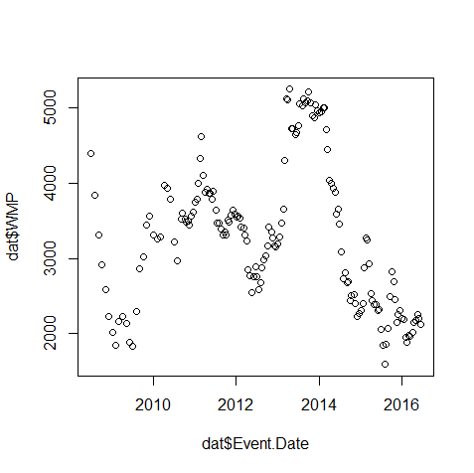

Some cyclical trends, prices hit a relative low every 2 years.

Work with WMP product contract weighted prices

> dat$Actual.Date.of.Event <- as.Date(dat$Actual.Date.of.Event, "%m/%d/%Y")

Analysis

> plot(dat$Actual.Date.of.Event,dat$CP1,xlab = "Date of Event", ylab = "Contract Period Weighted Price", col="red")

> points(dat$Actual.Date.of.Event,dat$CP2,col="blue")

> points(dat$Actual.Date.of.Event,dat$CP3,col="green")

> points(dat$Actual.Date.of.Event,dat$CP4,col="black")

> points(dat$Actual.Date.of.Event,dat$CP5,col="yellow")

> points(dat$Actual.Date.of.Event,dat$CP6,col="orange")

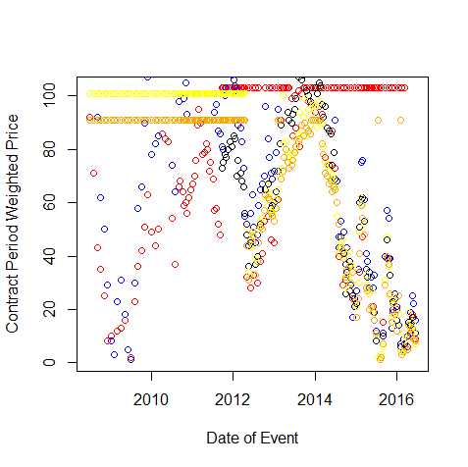

Trends similar to the first graph above, no surprise as the contract period prices make up the overall weighted price. Worth looking into why these prices cyclically fluctuate and if this can be incorporated into model.

> lm1 <- lm(ChangeTotal ~ ChangeCP1 + ChangeCP2 + ChangeCP3 + ChangeCP4 + ChangeCP5 + ChangeCP6, dat)

> summary(lm1)

lm(formula = ChangeTotal ~ ChangeCP1 + ChangeCP2 + ChangeCP3 +

ChangeCP4 + ChangeCP5 + ChangeCP6, data = dat)

Residuals:

Min 1Q Median 3Q Max

-0.5002 -0.3512 -0.1188 0.3716 0.7613

Coefficients:

Estimate Std. Error t value Pr(>|t|)

(Intercept) 0.50643 0.20705 2.446 0.050067 .

ChangeCP1 0.01714 0.01159 1.479 0.189642

ChangeCP2 0.32470 0.04761 6.820 0.000488 \*\*\*

ChangeCP3 0.11400 0.16159 0.705 0.506960

ChangeCP4 0.15476 0.16441 0.941 0.382875

ChangeCP5 0.35972 0.10017 3.591 0.011491 \*

ChangeCP6 -0.14074 0.10837 -1.299 0.241717

---

Signif. codes: 0 ‘\*\*\*’ 0.001 ‘\*\*’ 0.01 ‘\*’ 0.05 ‘.’ 0.1 ‘ ’ 1

Residual standard error: 0.5879 on 6 degrees of freedom

(153 observations deleted due to missingness)

Multiple R-squared: 0.9833, Adjusted R-squared: 0.9665

F-statistic: 58.73 on 6 and 6 DF, p-value: 4.576e-05

Contract period 2 is the best indicator of the weighted average price fluctuations for WMP. CP1 and 5 are also ok, but not nearly as accurate. 3, 4, and 6 have no strong correlation to the ending WMP weighted price. This reflects supply of WMP purchased for each contract period.

AKA whatever world events could indicate short-term buying of dairy products could be a strong tell into the final average weighted price for WMP.

> datChange <- data.frame(dat$ChangeCP1, dat$ChangeCP2, dat$ChangeCP3, dat$ChangeCP4, dat$ChangeCP5, dat$ChangeCP6, dat$ChangeTotal)

> lm0 <- lm(dat.ChangeTotal ~ 1, datChange)

> lmall <- lm(dat.ChangeTotal ~., datChange)

> step(lm0, scope=list(lower=formula(lm0), upper=formula(lmall)),direction="both",trace=1)

Step: AIC=-10.07

dat.ChangeTotal ~ dat.ChangeCP3 + dat.ChangeCP2 + dat.ChangeCP5 +

dat.ChangeCP6 + dat.ChangeCP1

Df Sum of Sq RSS AIC

<none> 2.3802 -10.0710

+ dat.ChangeCP4 1 0.3063 2.0739 -9.8617

- dat.ChangeCP1 1 0.6676 3.0478 -8.8571

- dat.ChangeCP6 1 0.7945 3.1746 -8.3268

- dat.ChangeCP3 1 2.9467 5.3269 -1.5983

- dat.ChangeCP5 1 7.4124 9.7926 6.3168

- dat.ChangeCP2 1 17.5704 19.9505 15.5680

Call:

lm(formula = dat.ChangeTotal ~ dat.ChangeCP3 + dat.ChangeCP2 +

dat.ChangeCP5 + dat.ChangeCP6 + dat.ChangeCP1, data = datChange)

Coefficients:

(Intercept) dat.ChangeCP3 dat.ChangeCP2 dat.ChangeCP5 dat.ChangeCP6

0.53948 0.24415 0.30503 0.40551 -0.16102

dat.ChangeCP1

0.01602

The final step function proves these claims, as removing the CP2 would cause the regression to be the worst indicator of weighted average WMP price. Not a lot of data used to conduct analysis as all NA values had to be omitted.